#### **ADVANCE SOFTWARE ENGINEERING**

#### MID-TERM REPORT

**Rakesh Videm**

**16159533**

**UMKC**

**Email: rvbnd@mail.umkc.edu**

#### **TRACE YOUR ROUTE**

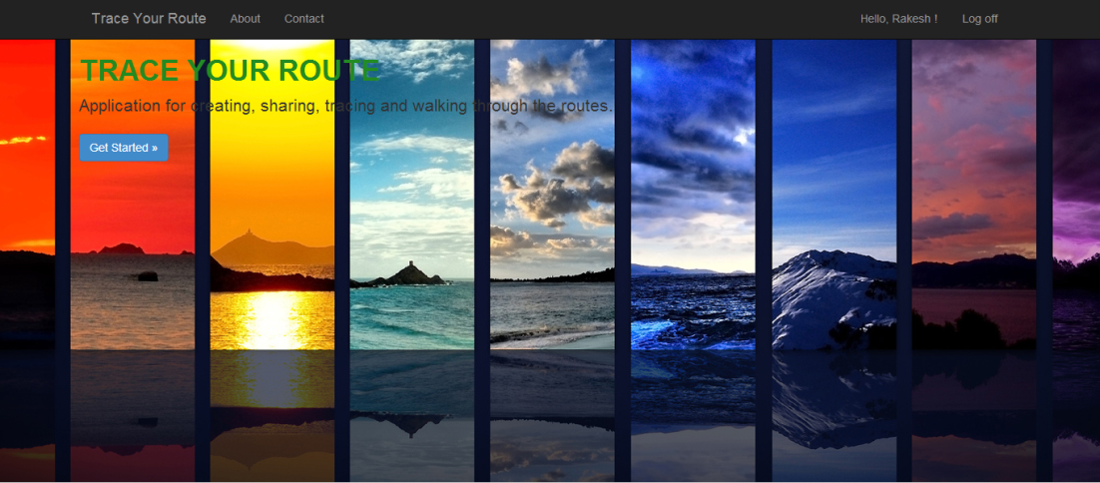

**Table of Contents**

1. Design
   1. Architecture Diagram
   2. Class Diagram
2. Features Implemented
   1. Web Services
      1. Your own services
      2. Existing services/APIs
   2. Database
      1. Your own data model/data sources
      2. Existing data model/data sources
   3. Mobile User Interface
      1. Your own design
      2. Existing design
3. Include Screenshots of the Features
4. Include all the Web Service and Web Site URLs
5. Include your midterm Github URL

Design

**Architecture Diagram**



**Class Diagram**



Features Implemented

**Web Services**

*Own Services:*

1. Creating a route.
2. Trace a route.
3. Choose and walk through the route.
4. Email Support.

*Existing Services:*

1. Foursquare Search Places.
2. Google Maps.
3. ASP.NET Register and Login Service.
4. Facebook Share Service.
5. Twitter Tweet Service.

**Database**

*Own Data model/data sources:*

1. Back ground Image.
2. Web Page design.
3. All web forms design.

*Existing Services:*

1. ASP.NET Master Page design.

**Mobile User Interface**

*Own Design:* Mobile web Page

*Existing Design:* Opera mobile Emulator.

Screenshots

**Home Page**

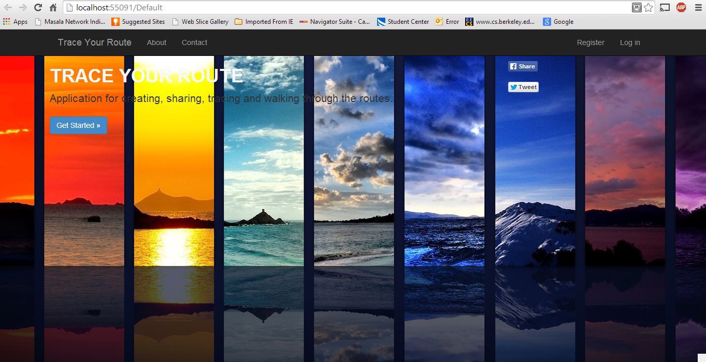

**About Page**

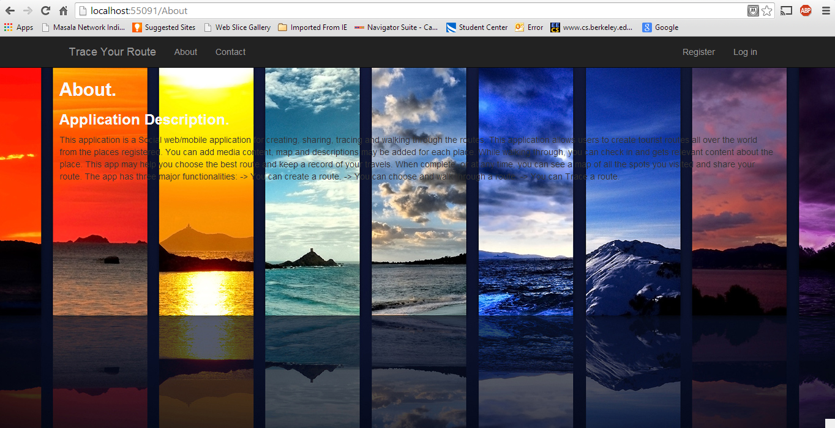

**Contact Page**

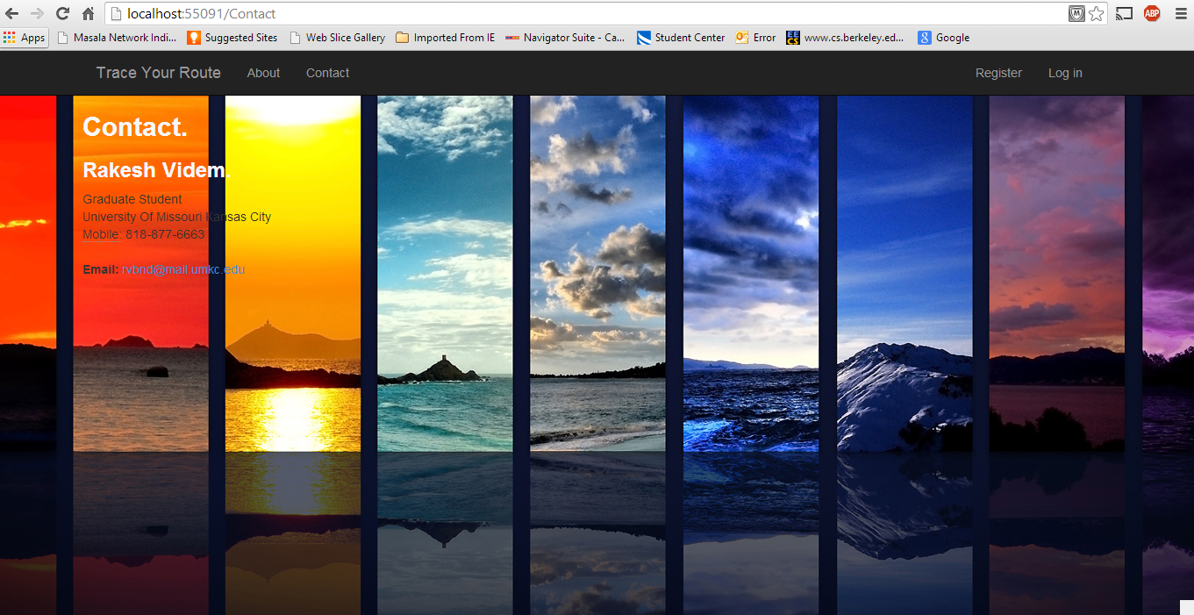

**Email Support**

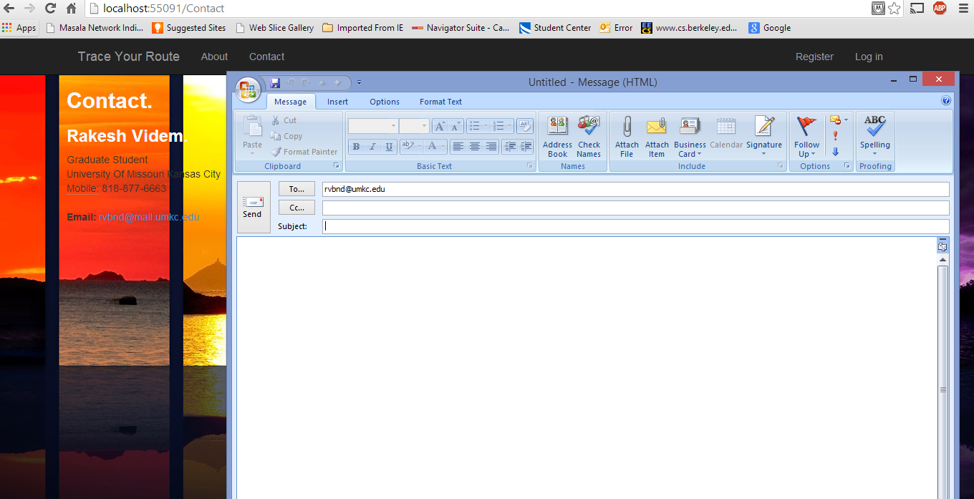

**Register**

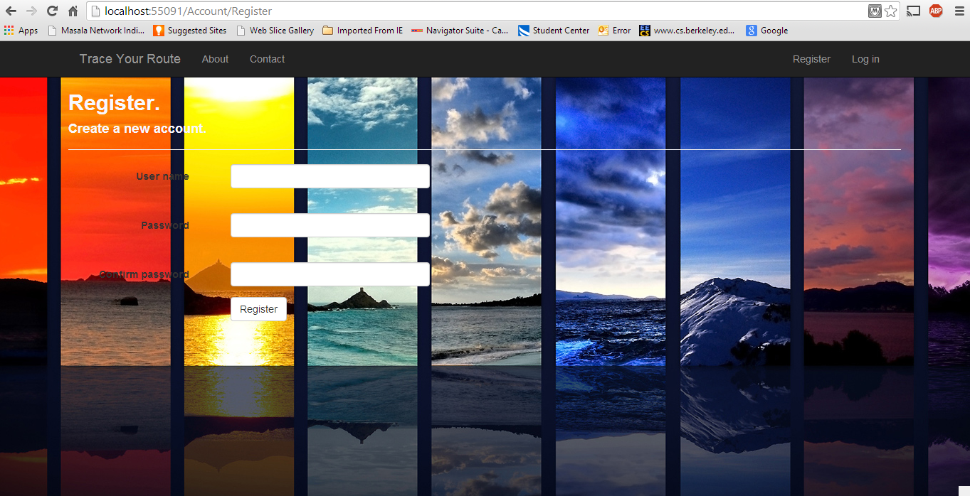

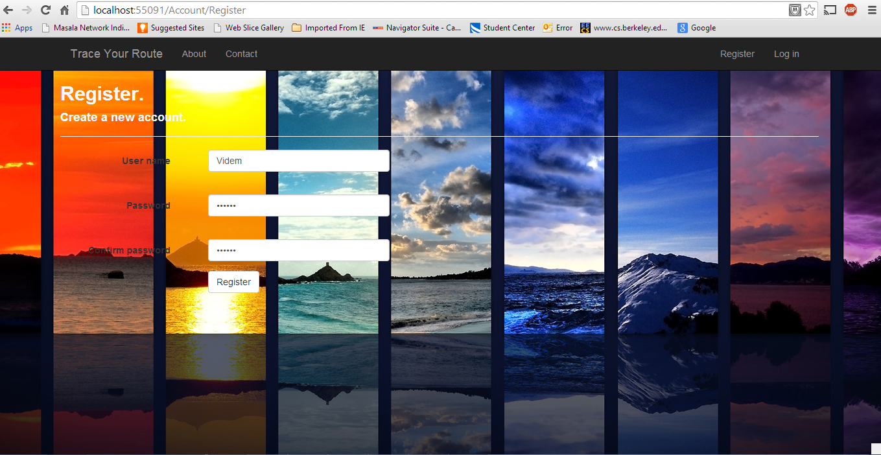

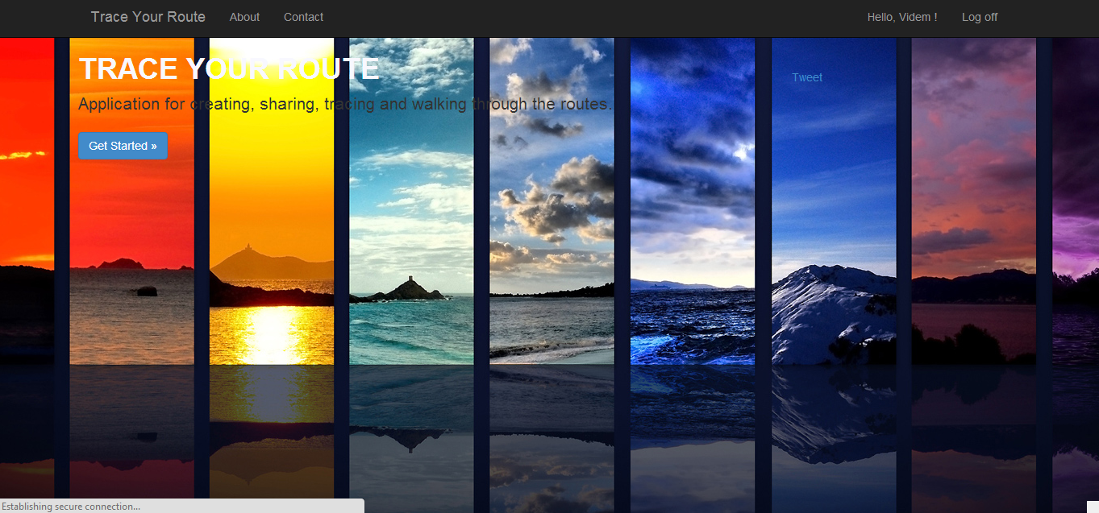

**Login**

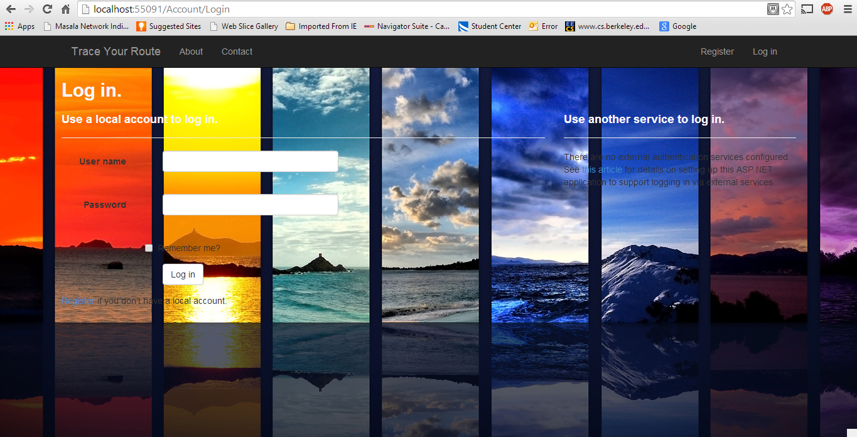

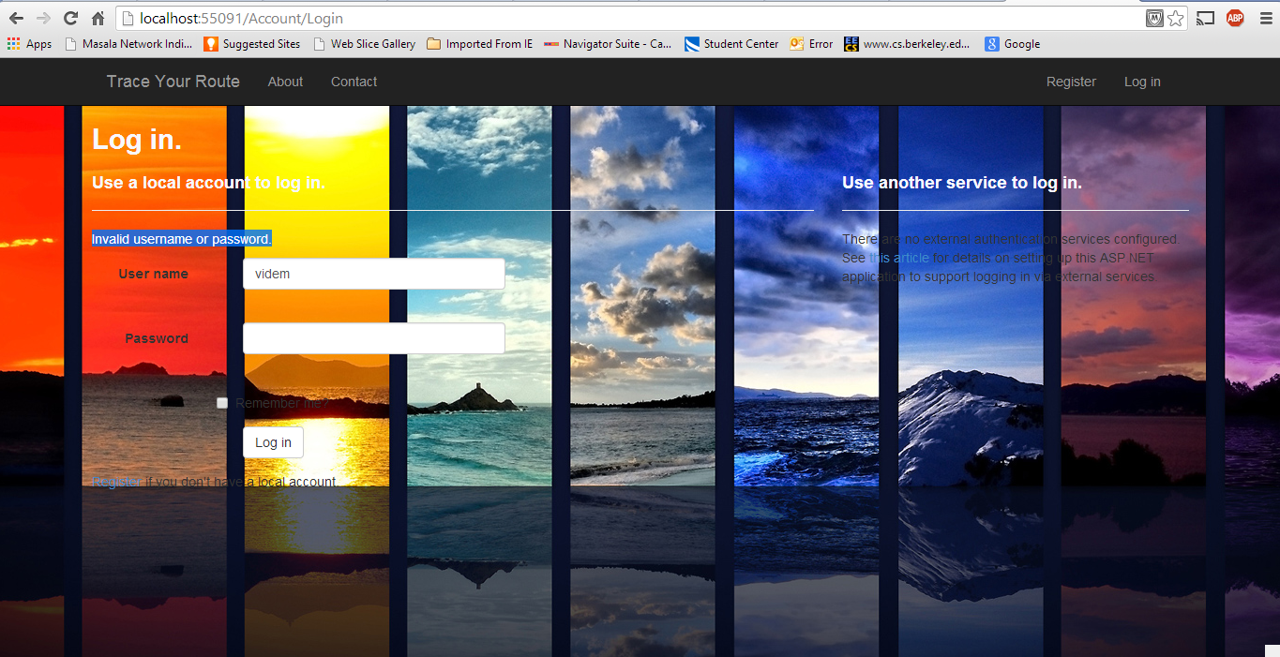

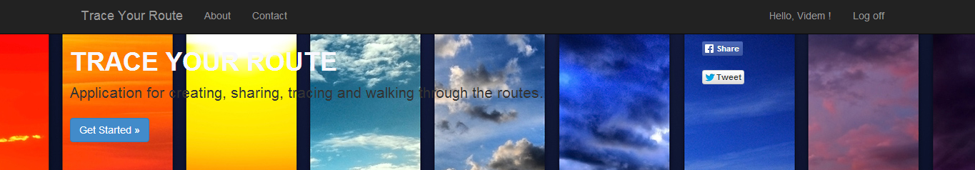

**Get Started**

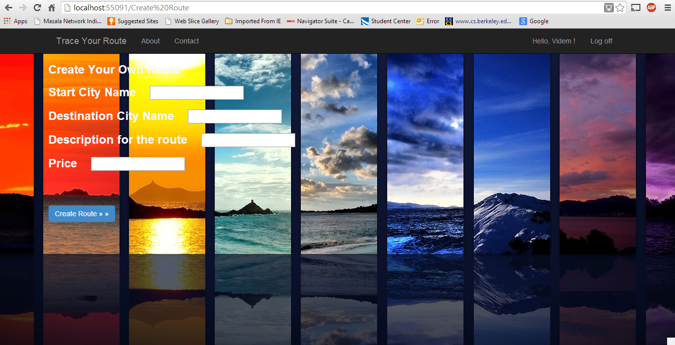

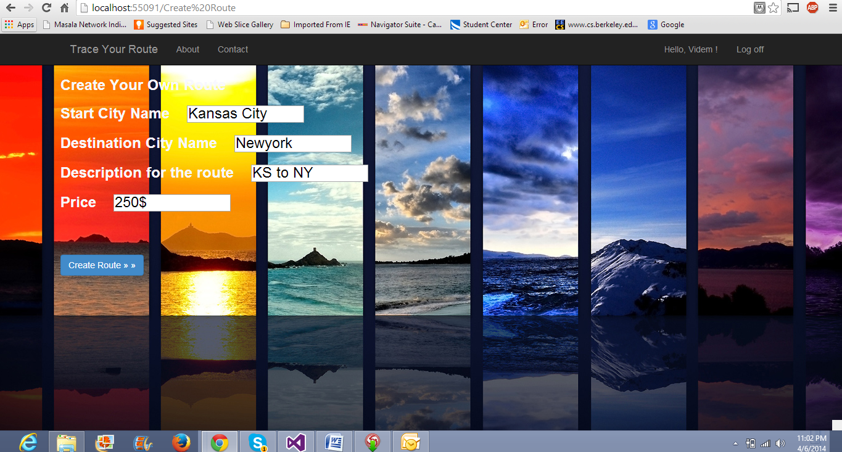

**Create Route**

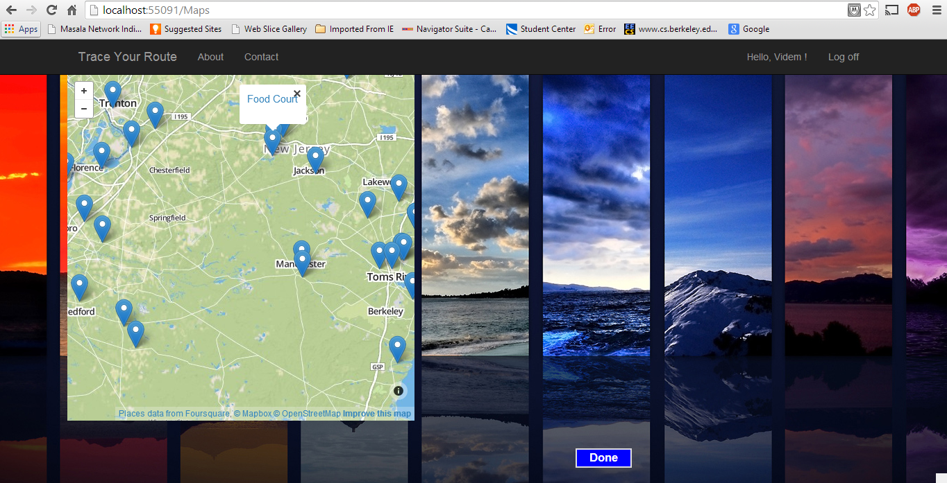

Github URL

**https://github.com/rvbnd/Midterm**

References

* Foursquare website <https://foursquare.com/>
* Google Developer Site <https://developers.google.com/>
* Foursquare API <https://developer.foursquare.com/start>
* Twitter Developer Site <https://dev.twitter.com/>
* Facebook Developer Site <https://developers.facebook.com/>